Voter User Guide

About the system
This guide covers the Biometric E-Voting System, an electronic voting platform developed to strengthen electoral integrity in the UK through fingerprint authentication. The system replaces traditional paper ballots with a secure digital process that verifies voter identity biometrically, records votes anonymously, and allows polling station staff to manage the process in real time.
The system consists of two desktop applications:
- The Official App — used by polling station staff to register voters, link devices, monitor station activity, and manage voter devices remotely.
- The SecureVote App — used by voters at the polling terminal to authenticate via fingerprint and cast their ballot.
Both applications communicate through a cloud-hosted server, which handles fingerprint matching, encrypted data storage, and real-time updates between devices.
This guide is intended for two audiences: polling station officials responsible for setting up and managing the system on election day, and voters using the SecureVote App to cast their ballot. Each section is clearly labelled so you can go directly to the part most relevant to you.
No technical background is required to use either application. If you encounter a problem not covered in this guide, please contact your supervising election officer.

Connecting a Voting Device to a Polling Station
To connect a device you must first log into your official account.
You will then go and generate a code for your polling stations.
This can be found at the top left of the menu screen.
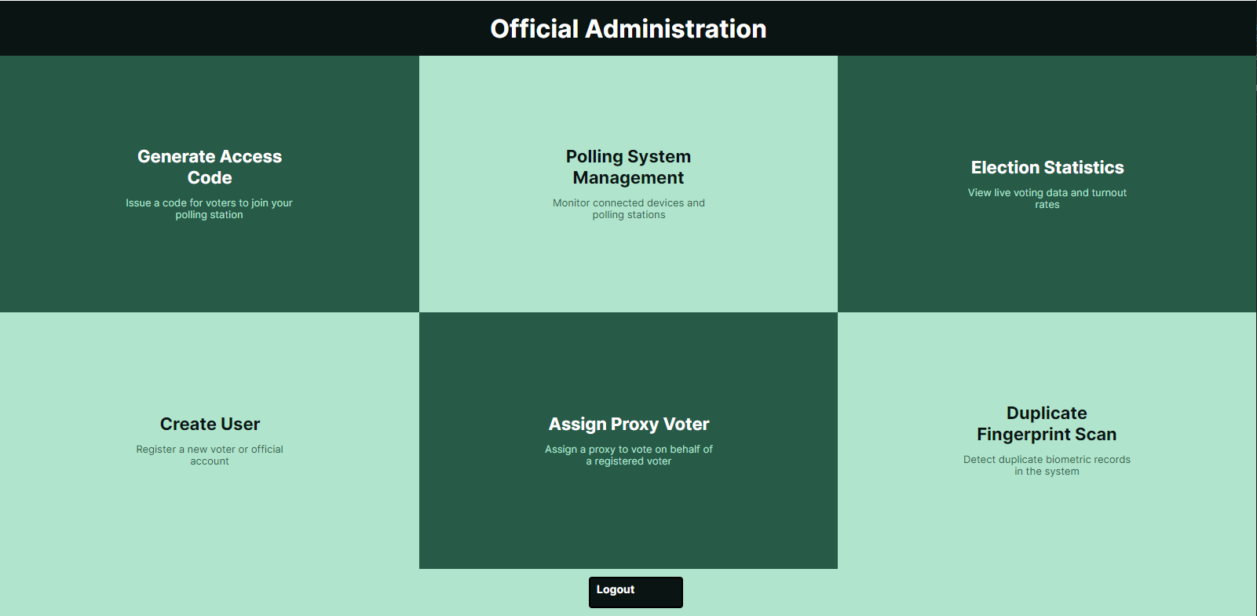
Once inside of the Generate Access Code screen you must enter a code into the text box. Once this is complete press the generate button. If your code is not unique you must try a new code, the code you choose can be completely random. You are encouraged to choose a random word that isn’t associated with your daily life or identity. This could look like “BannanaDirt47”.
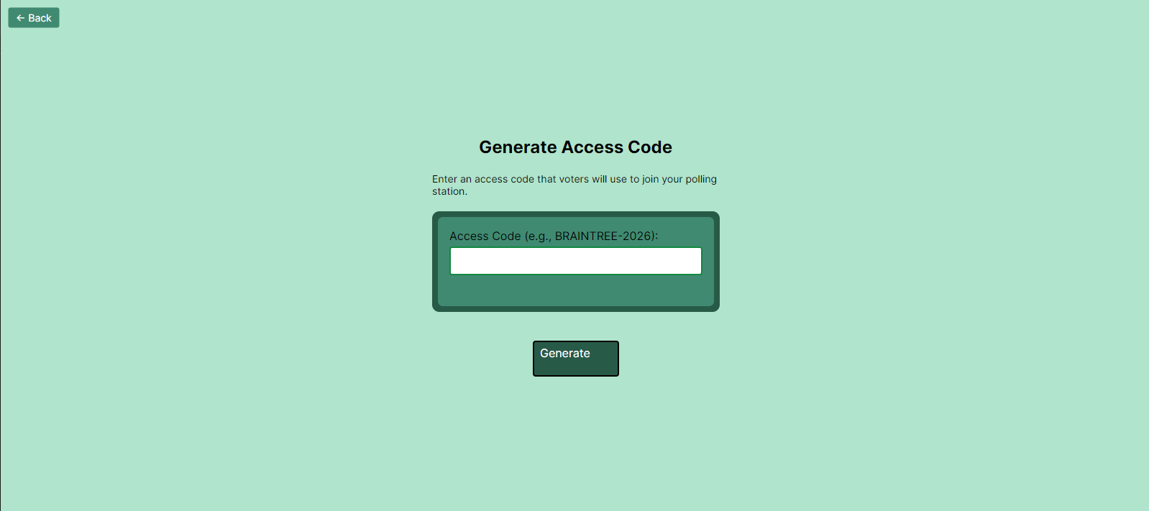
Once you have generated this code successfully you will then move onto the device you wish to connect to your polling station. Once you have opened the secure vote app you will be shown the linking screen. Here you will enter your county, constituency and linking code you generated earlier. 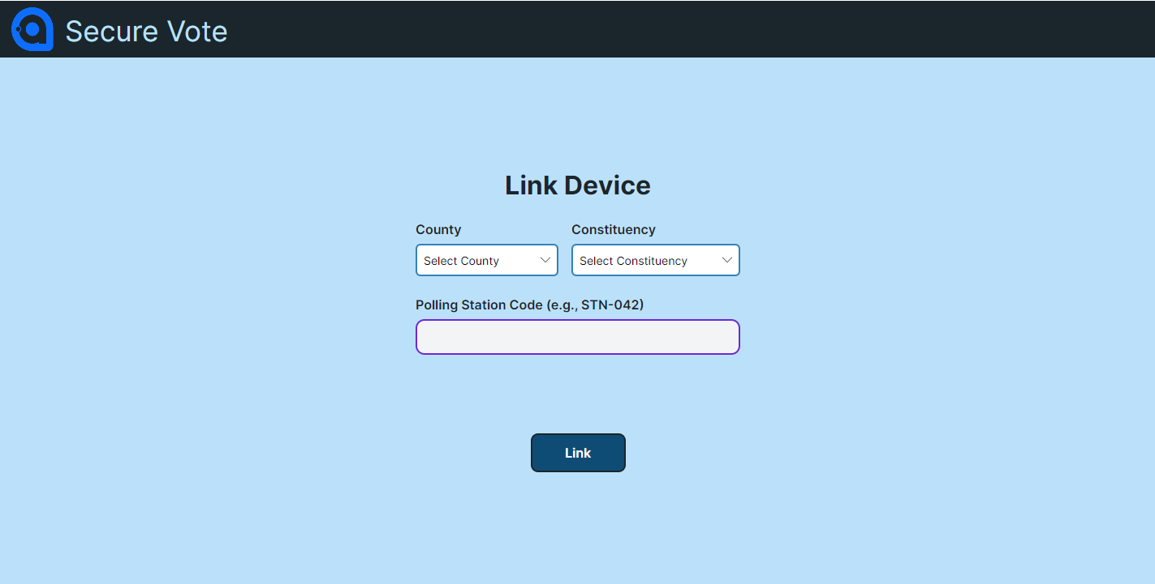
If all details are in order you will have successfully linked the device to the polling station. If you enter any details in incorrectly the app will tell you what you have done wrong and you simply try again. When a successful link has occurred you will be greeted by this screen. 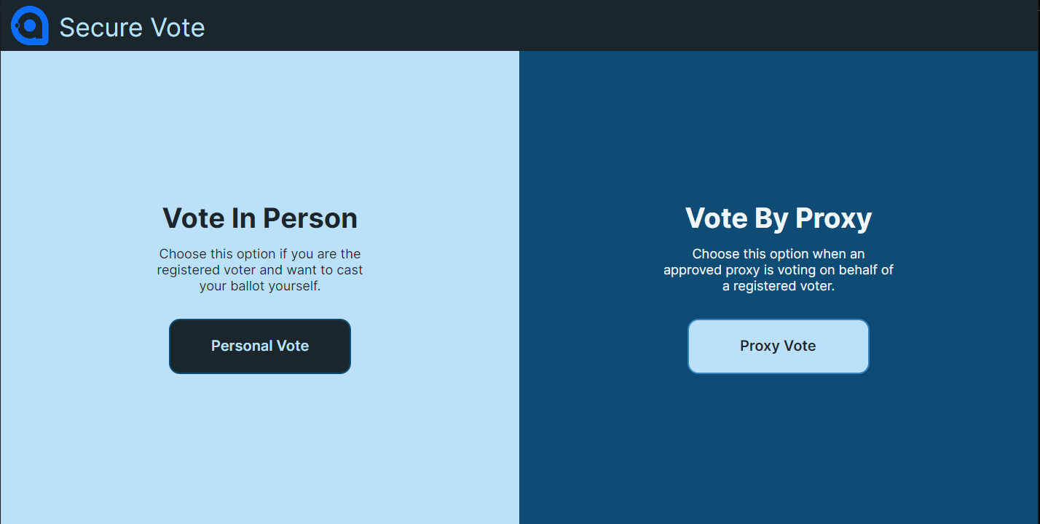
Now the voter device is set up and able to be used by a voter.

Creating a User
To create a voter first you must navigate to the Create User tile located at the bottom left of the polling station app. 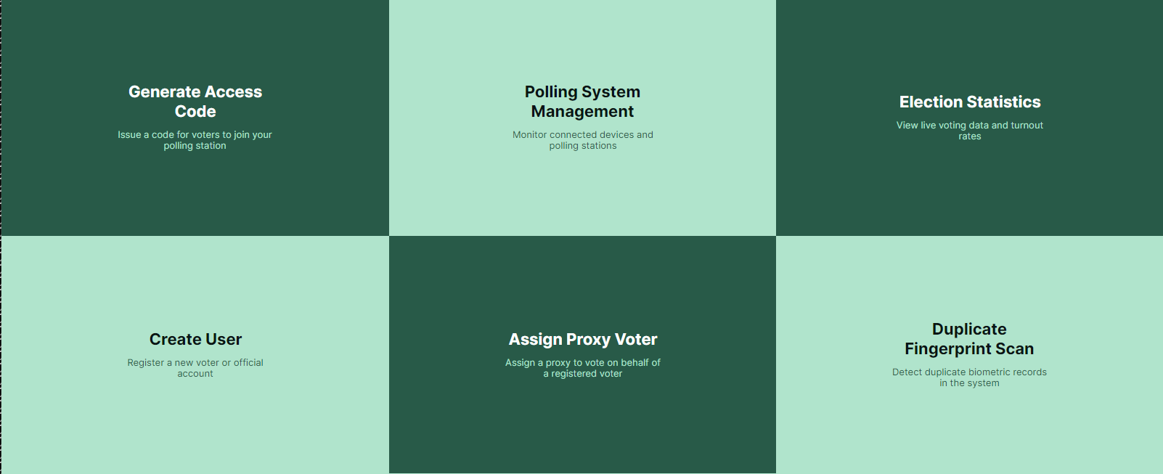
Once in the tile you will be given a choice to create either a Voter or an Official. The process is very similar to each other. For a vote you must collect all information that is presented to you in the text boxes. 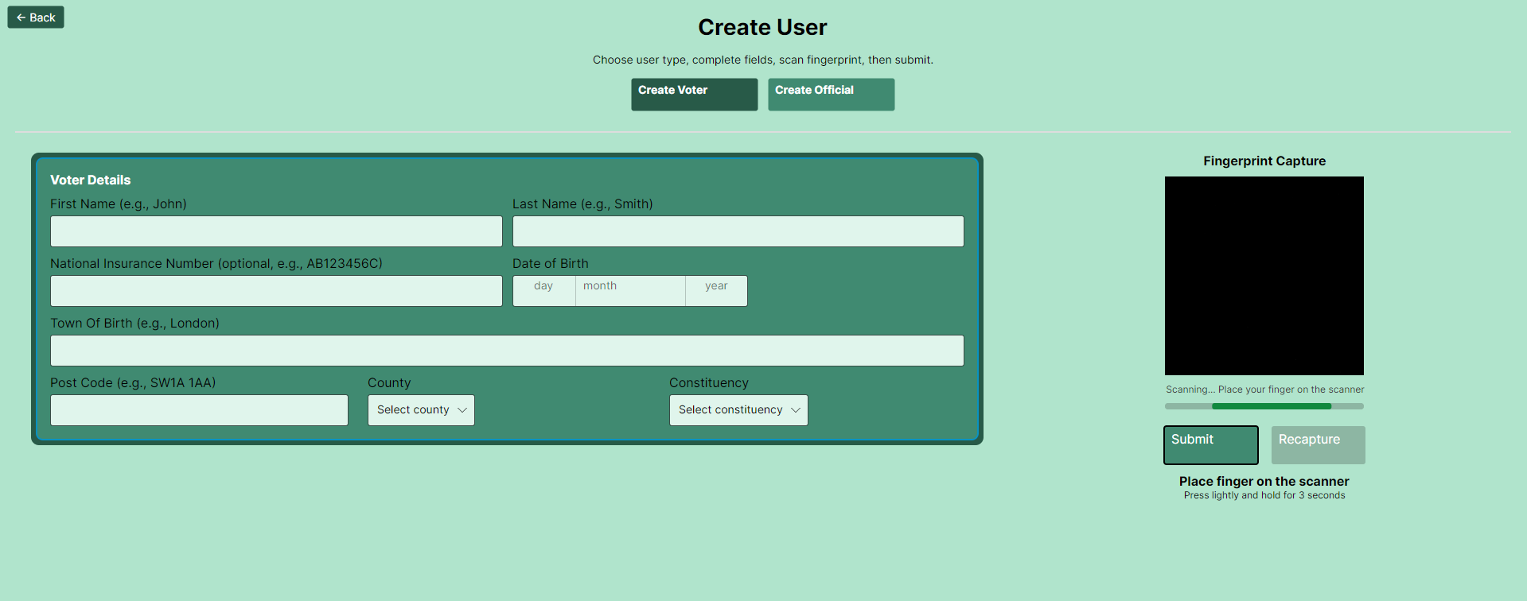
A voter can not have an insurance number, so this field can be left blank if they do not have one. After the information has been filled in ask the voter to scan their fingerprint. The scanner will be active all the time until a fingerprint has been captured. If the fingerprint does not look satisfactory you can recapture a fingerprint by pressing the recapture button. If all is in order then proceed with the creation of the Voter by pressing the submit button.

If you are creating an official then process is the same. You must collect all information from the voter that is on the screen. The official should have been assigned a polling station which you can find using the drop down menu. You must ask the official to enter in their password them selves and you cannot do it for them. The same rules apply for fingerprint scanning as mentioned last paragraph. 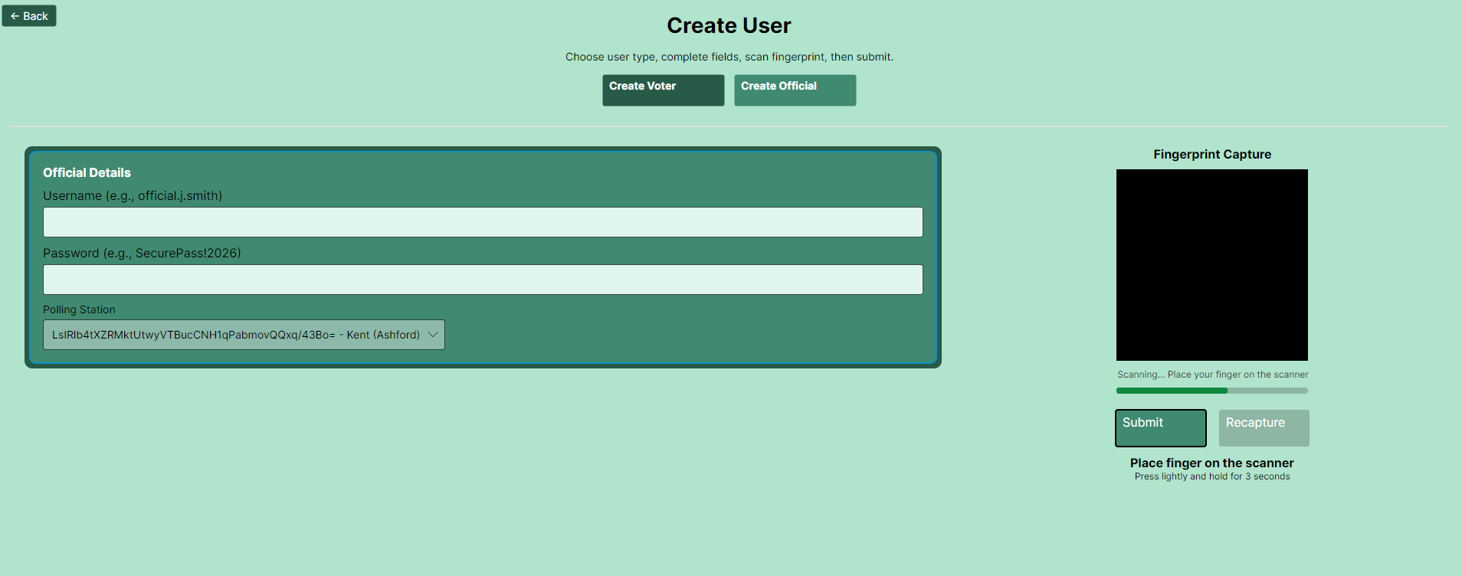

Assigning a proxy voter
To Assign a proxy voter you must first navigate to the assign proxy voter tab, this is located in the middle of the bottom row of the official menu. 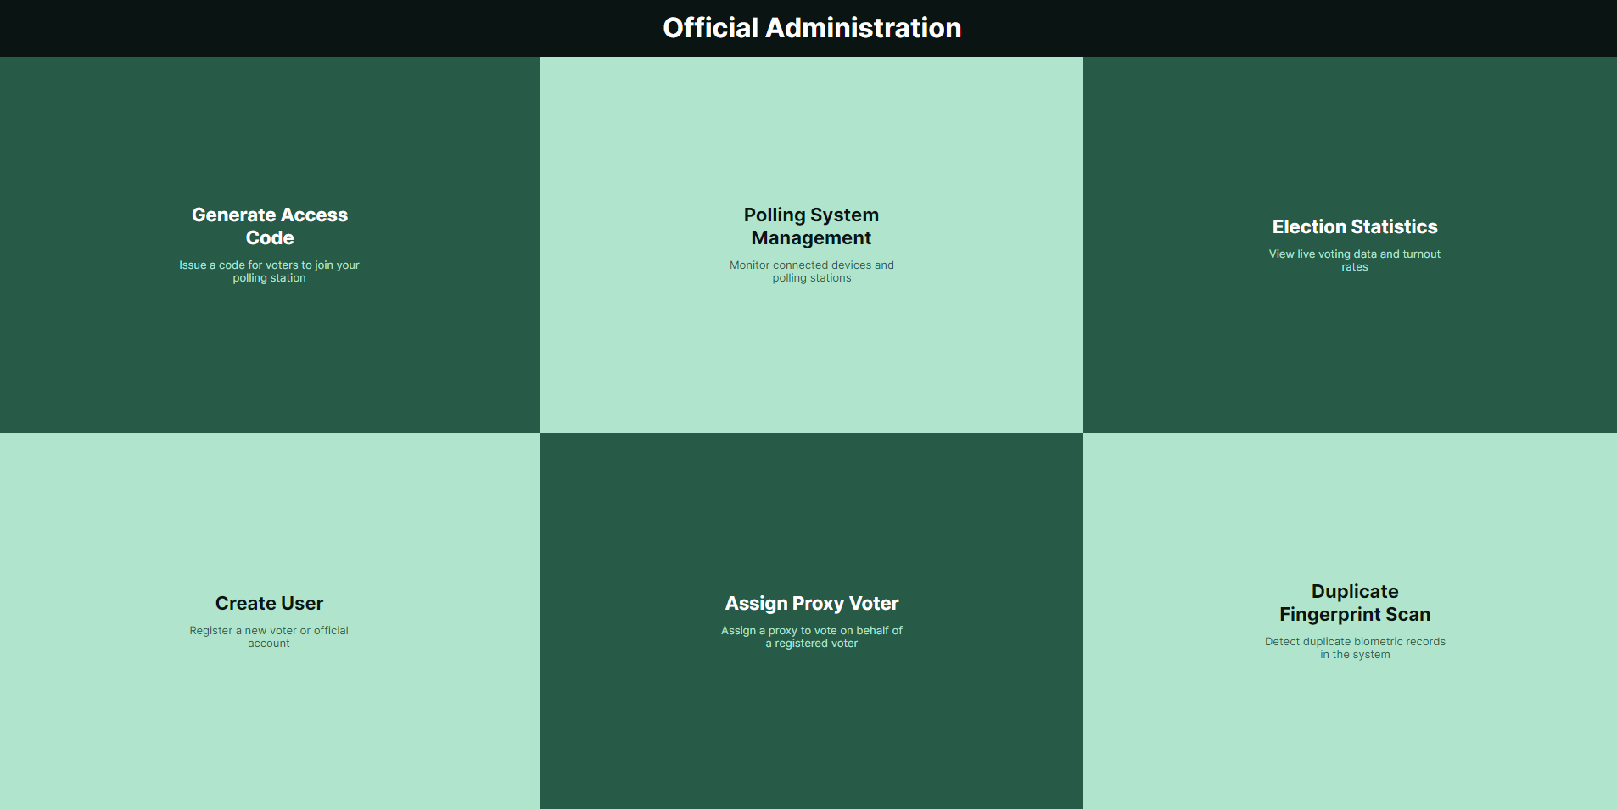

Once in the menu you will need to extract all info from the voter that is requested in the text boxes. Start by gathering the Represented Voters information first, this is the voter who has come to assign a proxy voter to represent them in the coming election. Then enter in the details of the Proxy Voter, this is the voter who will be voting on the behalf of the Represented Voter. Once this information has been entered the Represented Voter must scan their fingerprint. Once scanned look to see if the image captured is clear, if not you can attempt a recapture by pressing the recapture button. Once you are happy with the details collected you can then press the assign button. If the details are incorrect or one of the two voter types are not recorded in the database the assigning will be rejected. Collect the information from the voters again and re attempt assigning. If this continues to fail ensure that both voters are registered to vote on this system. Then try again.
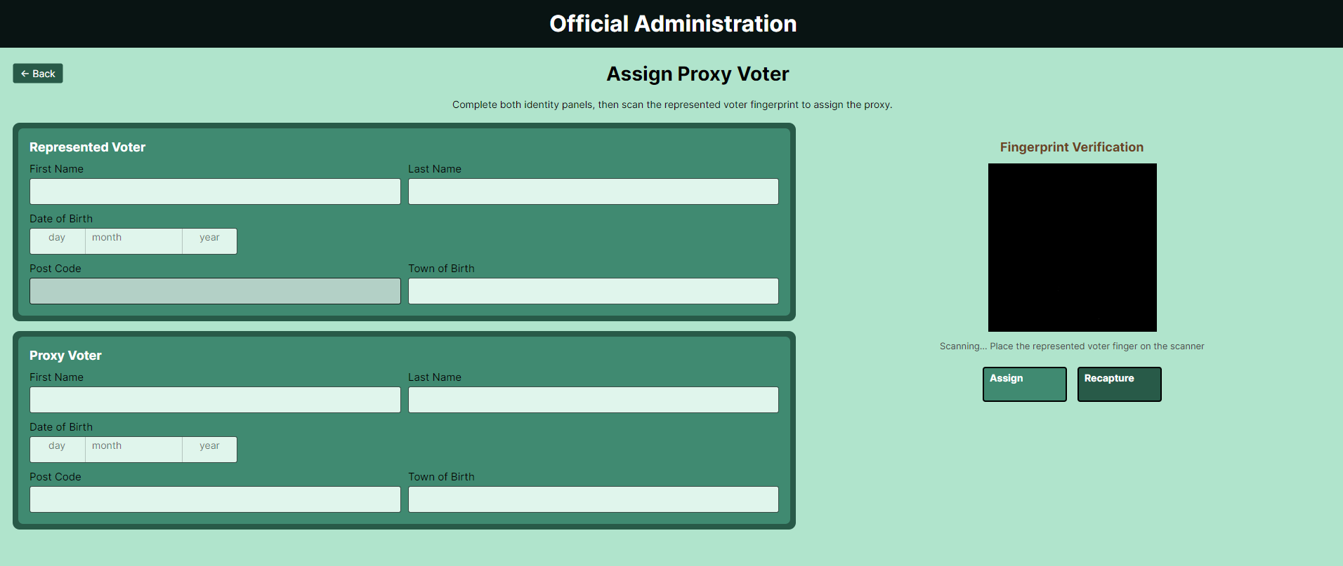

Casting a Personal Vote
To cast a personal vote you select the Vote In Person tile on the left hand side of the screen.
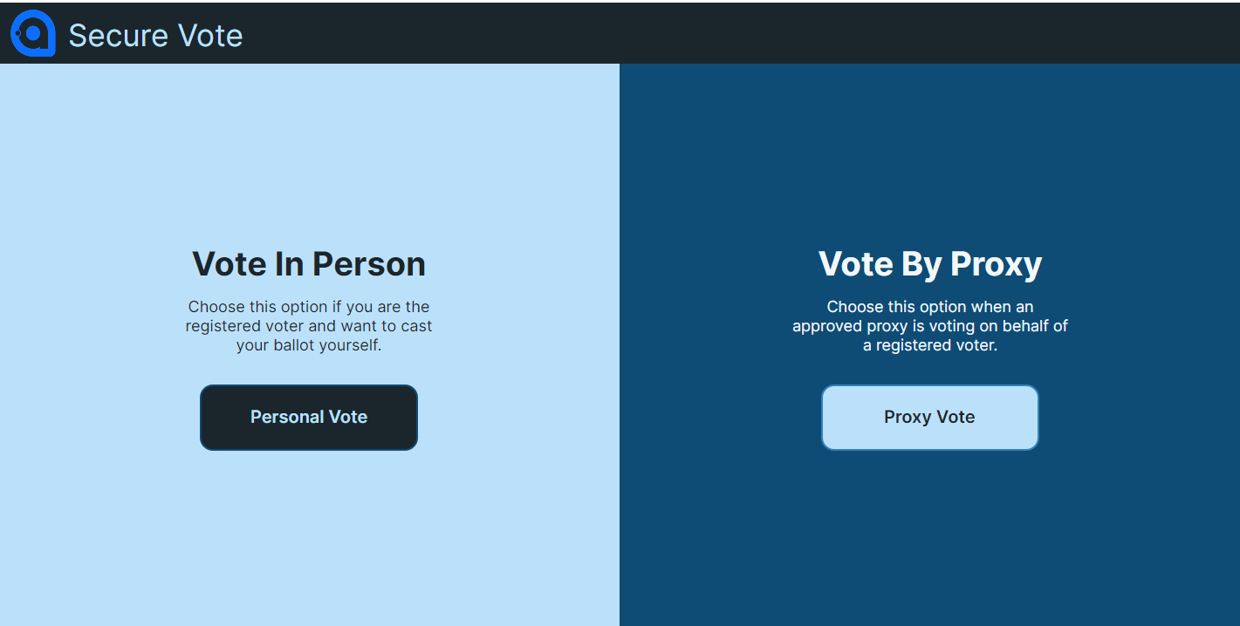

Now that you are in this screen you enter the details that are requested exactly as you entered them when creating your account on this system. Then once you have entered them in you press authenticate.
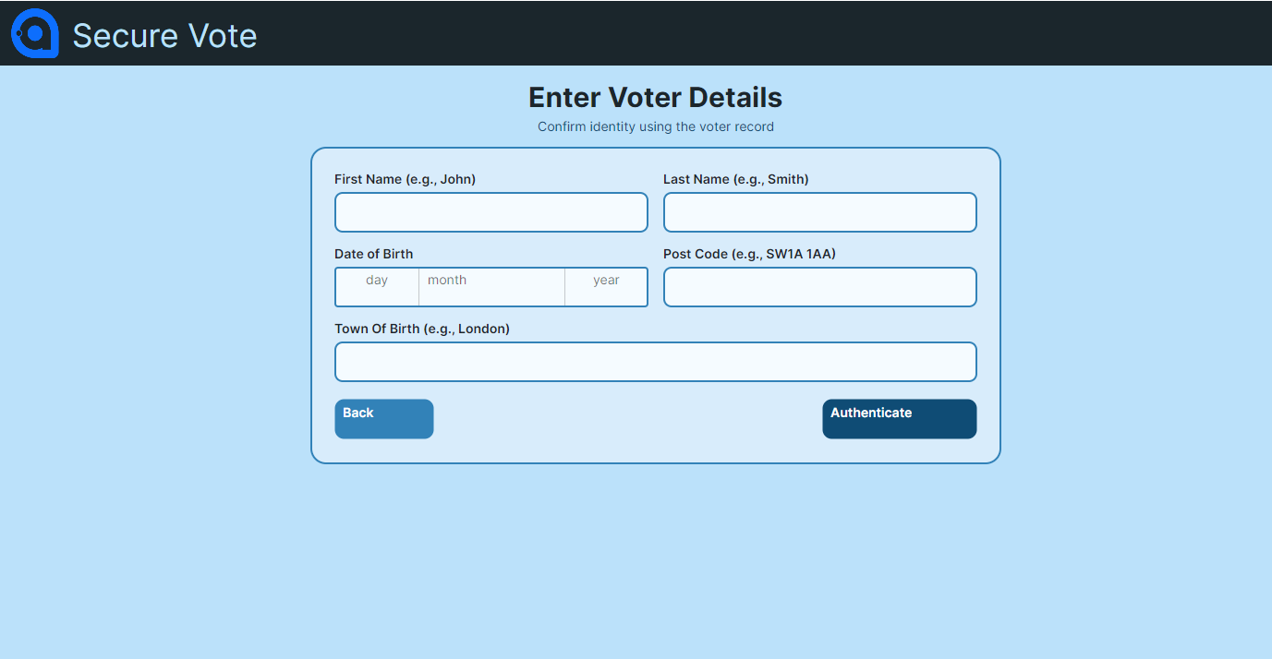
You will then be presented with the scanning screen. Follow the instructions on the screen and guidance will be given to the voter. 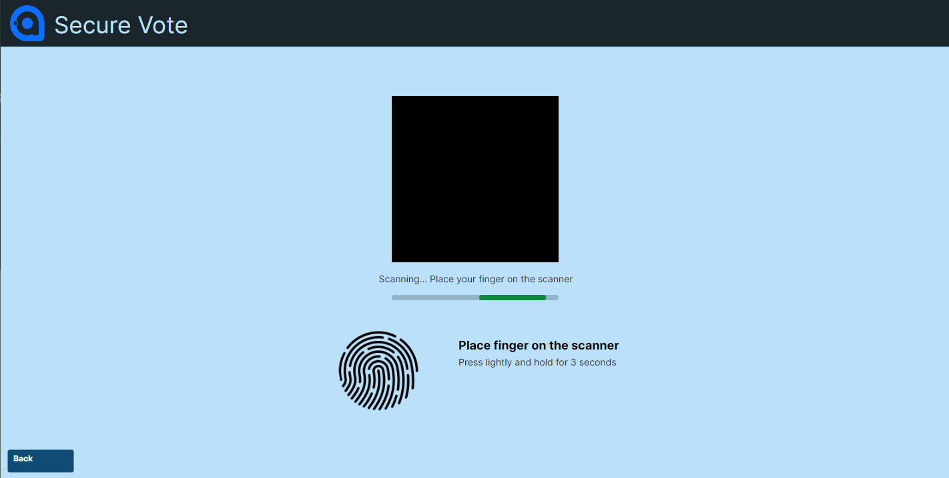
Now that you are authenticated you can cast your vote. Select any candidate you see fit and press cast vote. Once you cast vote the screen will return to the selection at the beginning. 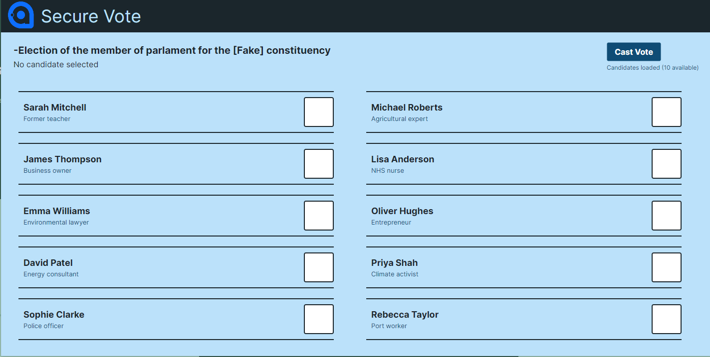

Casting A Proxy Vote
To cast a proxy vote it is very similar to the personal vote. Select the tile on the left.
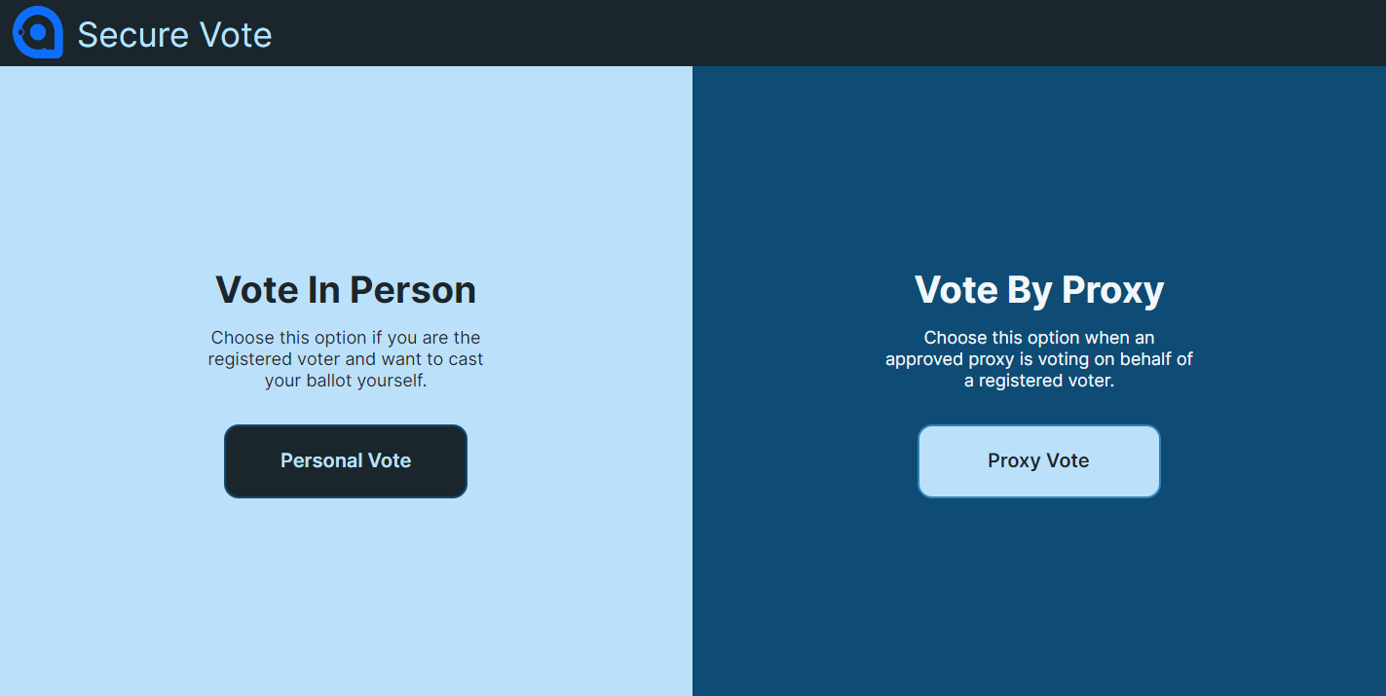

Once inside of this tile you will see two areas to enter in the details of the represented voter and the proxy voter. Once these details have been entered in the proxy voter must press authenticate where they will follow the same steps as the personal voter does. Then after this the ballot will be cast as usual. 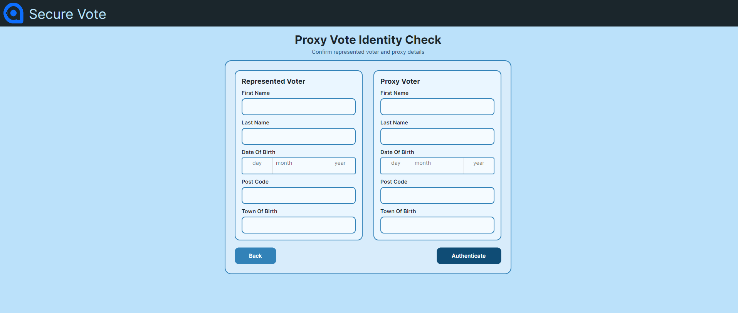

How to lock a Voting device
To see the list of devices first you must enter the polling System management tile found in the middle of the top row. 
Once in this tile you will be presented with the connected devices on the left and the polling stations data on the right.

If you wish to lock a connected device you need to press the lock button. This will return the screen of the voter device to the link screen.
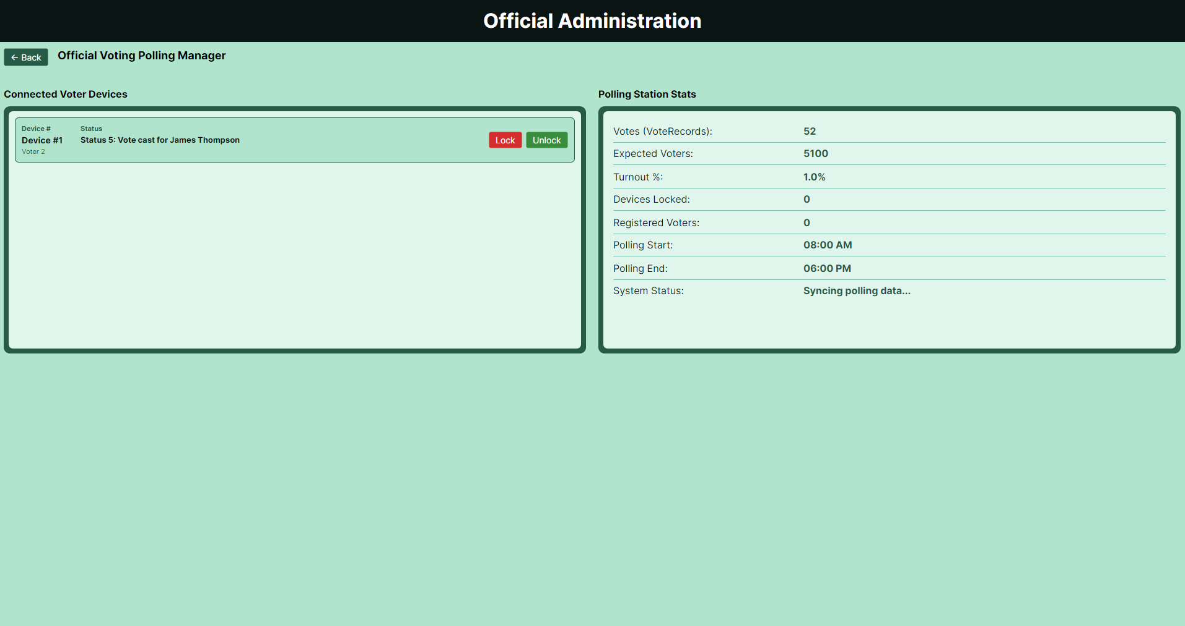
When a device is locked you will see this text on the link screen of the locked device. 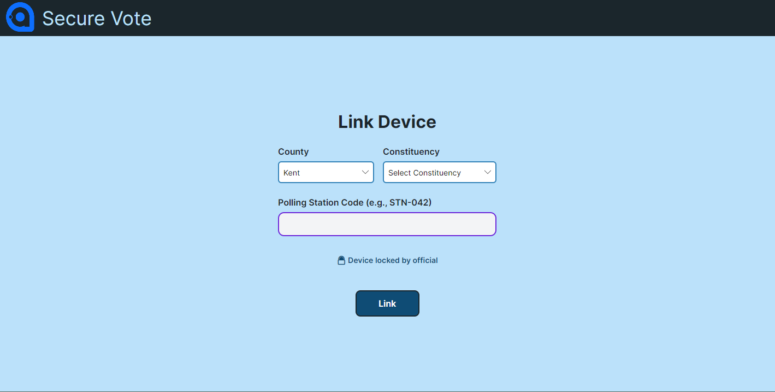
Once you deem its safe to unlock the device you can simple press the unlock button on the tile you locked on the polling system management screen and you will be able to re enter the linking details. Re linking the device to the polling station.

